PURCHASING BOARD FOR MULTIPLE FORMS / SHEETS

Adding a purchase for a set, combination or tandem job allows the options to add a single board material for one or more forms. However, the roll width or sheet sizes must match. For corrugated materials, the panel sizes must match so all the sheets are scored exactly the same. Each panel is a combination of the inside box dimension plus an allowance for folding the box. Think about putting laser paper inside of a box. Looking down into the box, the inside dimensions would be 8.5 x 11 but the outside must be larger to fold up properly.

The difference between corrugated and folding cartons is the paper thickness. Paperboard in the folding industry can be folded without any allowances. Paperboard in the corrugated industry is too thick to just fold without increasing the panel size.

For example, the estimate 314 below is for a box length, width and depth of 10x10x10 respectfully. The style file has the formula for the panels. For example the Blank Width (Top to Bottom) is .5W +D+.5W. A folding carton board material without scoring allowances would have panels sizes of 5 + 10 + 5. However, the corrugated style file transfers the score allowances to each panel. The net result is 5.02 + 10.06 + 5.03. Likewise, the Length is J + W + L +W +L or 1.08 + 10.02 + 10.03 + 10.03 + 10.02

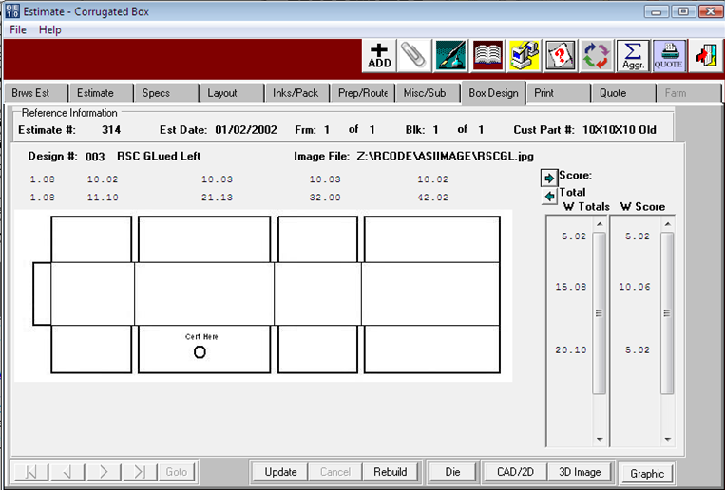

PURCHASING BOARD FOR MULTIPLE FORMS / SHEETS

The above box panel sizes are built from the SPEC Folder below. The SPEC panels also transfer to the PO Line Item Folder. The OVERRIDE Button will display the Blank Width Panel Sizes and Blank Length Panel Sizes. PLEASE NOTE, NORMAL GRAIN USES THE WIDTH PANELS ON THE PO. SHEET and BLANK cross grain will transfer the LENGTH PANELS to the PO Line.

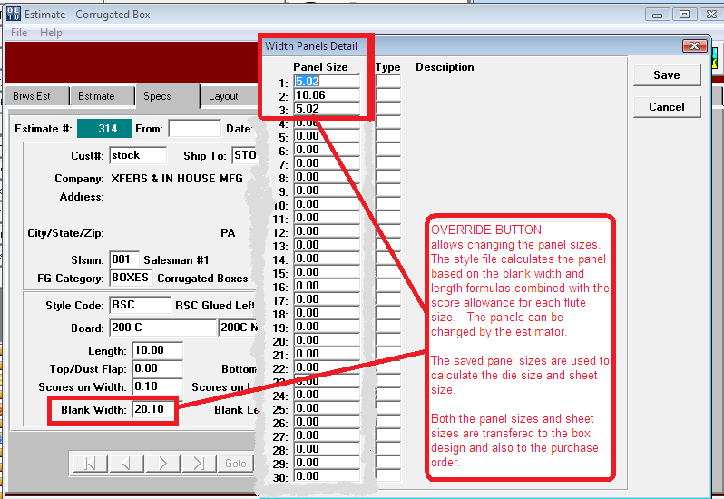

PURCHASING BOARD FOR MULTIPLE FORMS / SHEETS

The sample below is for the PO for 200C to produce the 10x10x10 box above. The button called SCORES on the bottom right will pop up the panel sizes that were tranferred from the SPEC folder. So, the PO logic for combining sheets for many forms must look at both the sheet size and the panel sizes.

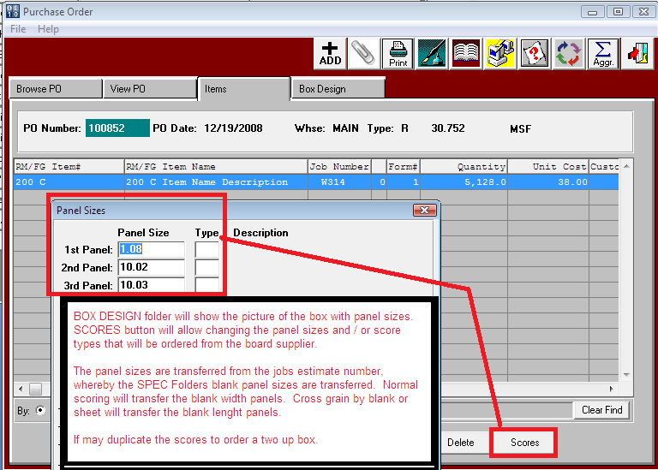

PURCHASING BOARD FOR MULTIPLE FORMS / SHEETS

For Sets, Tandem and Combination Jobs, the same roll or sheet may be added for all the forms. Enter a ? on the Sheet number above or press the F1 key to select which forms / parts to combine the total quantity needed for this job. This will transfer the quantity and cost for all forms selected.

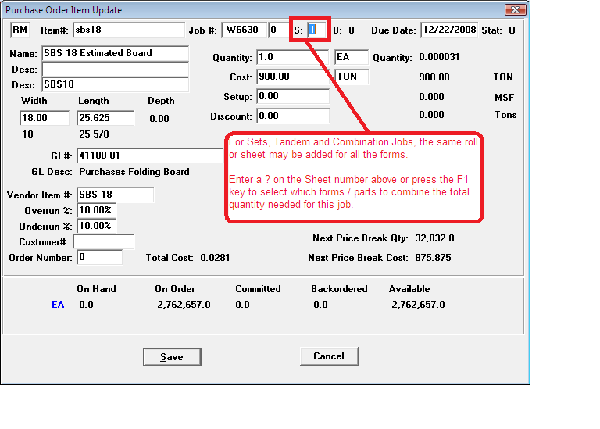

PURCHASING BOARD FOR MULTIPLE FORMS / SHEETS

When the cursor is on the Sheet / Form number, pressing F1 will show all forms for the job. The purchasing agent can select any number of forms. Once selected, the program will validate to make sure that all forms are the same size and same panels. If they do not match, a warning message will appear forcing the selection of only forms with identical sizes.

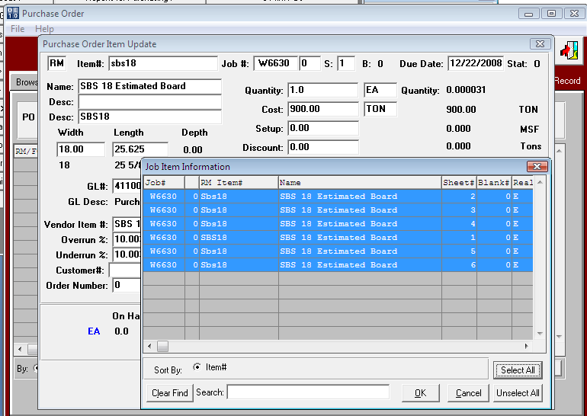

PURCHASING BOARD FOR MULTIPLE FORMS / SHEETS

After selecting all the forms, notice the screen is populated with a ? for the Sheet / Form number and the total quantity needed for all forms from the jobs MRP quantity is transferred to the purchase order. The system will also calculate the cost based on the cost for the total quantity.

